Mock CAT-10 (2004) Answer Key corrections

Answer Key corrections:
Q.32 (3) is the answer instead of (4). Q.43 (1) is the answer instead of (4).
Q.69 (1) is the answer instead of (2). Q.81 (1) is the answer instead of (3).
Q.86 (4) is the answer instead of (1). Q. 95 (4) is the answer instead of (1).
Q.100 (2) is the answer instead of (4).

Explanation corrections:
Q. 32, Page 3:
Combining both statements, the total number of votes can be found.
i.e. 1000.
Q.43, Page 4:
Read the last three lines as:
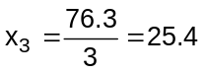
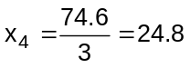
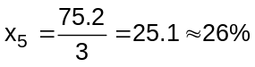
Q.69, Page 6:
Read the last two lines as:
Coefficient of x⁴⁹ = –(1 + 2 + 3 + ……+ 50)
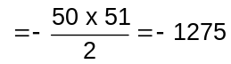
Q.72, Page 6:
Read the last line as:
Statement IV is valid for all integral values of x.

Q. 81, Page 7:
Explanation is:
The series is 1, x, xy, x²y, x²y², x³y², x³y³……..
The is same as the sum of 2 G.P’s to infinity terms,
(1 + xy + x²y² + x³y³+…..) + (x + x²y + x³y²+….)
Their summation is 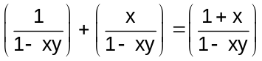.
Q.86, Page 8:
Explanation is:
It is not mentioned that triangular pyramid is regular. So we cannot find the total surface area of new.
Q.100, Page 9:
Add the line in the end:
In G.P., 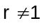
So r = - 2

